**Supplementary Figure 11**

**ROCs for IL-17 pathway prediction for Fig. 5A and Dendrograms for Fig. 5B**

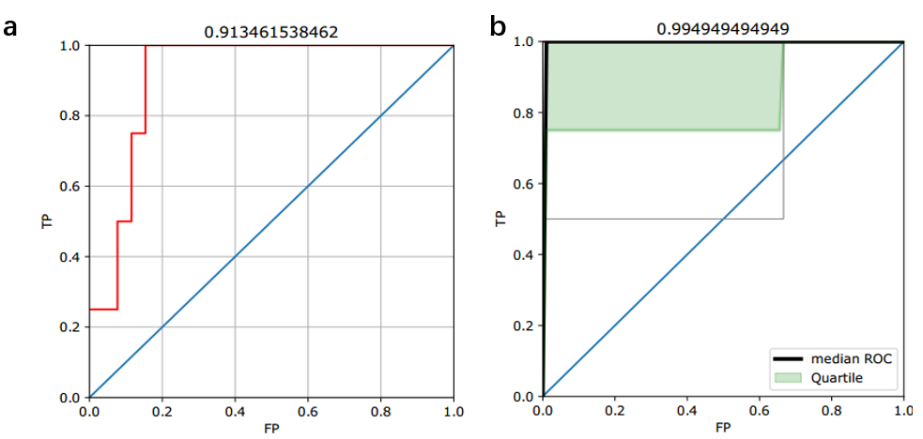

(**a**) ROC of the prediction of label 1 for all IL-17’s 30 directed edges. (**b**) Overall ROCs of prediction of label 1 for each protein with outgoing edges (nfkbia, map3k7 and traf6).

**Supplementary Figure 12**

**Software pipelines for users**

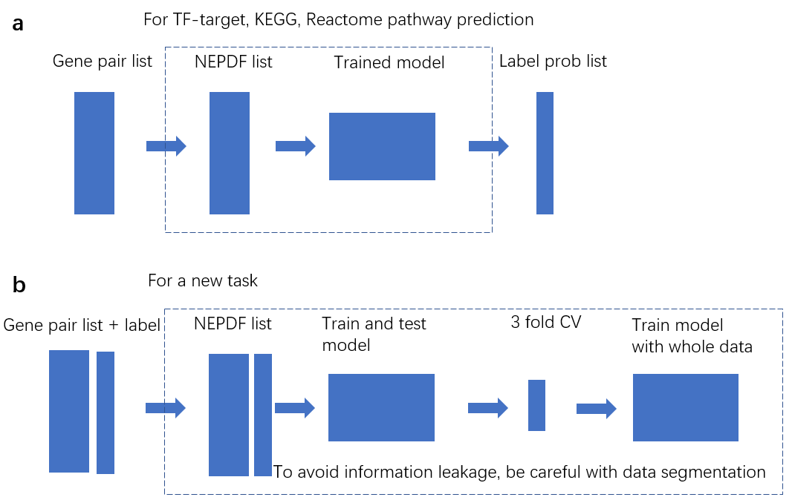 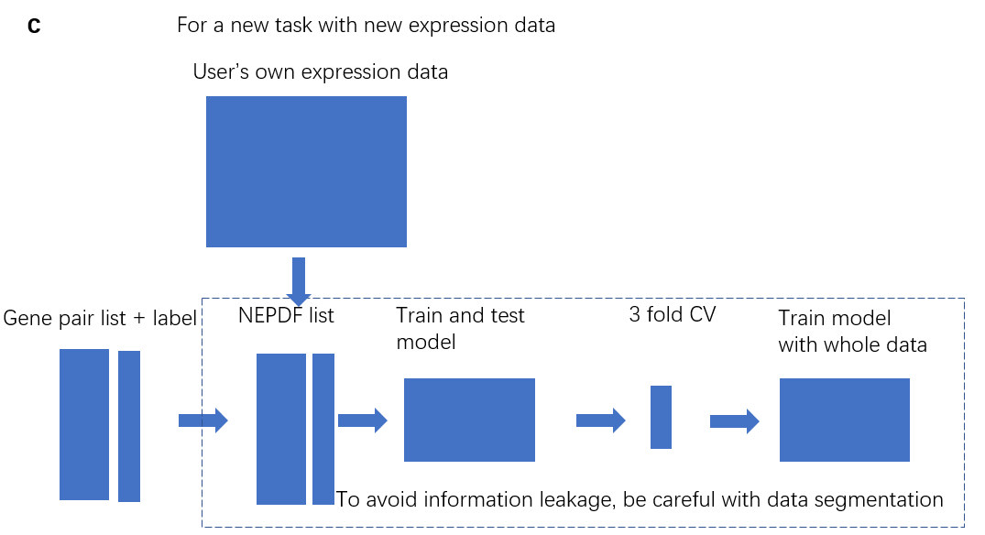

(**a**) Pipeline for TF-target, KEGG and Reactome edge predictions. Users only need to provide gene-pair candidate list. (**b**) Pipeline for a new task with the expression data we collected. Users need to provide gene-pair candidate list to generate NEPDF list and label list to train and test model. (**c**) Pipeline for a new task with the expression data users collect. Users need to provide gene-pair candidate list, their own expression data to generate NEPDF list, and label list to train and test model.

**Supplementary Figure 13**

**Training convergence plots for Fig. 4**

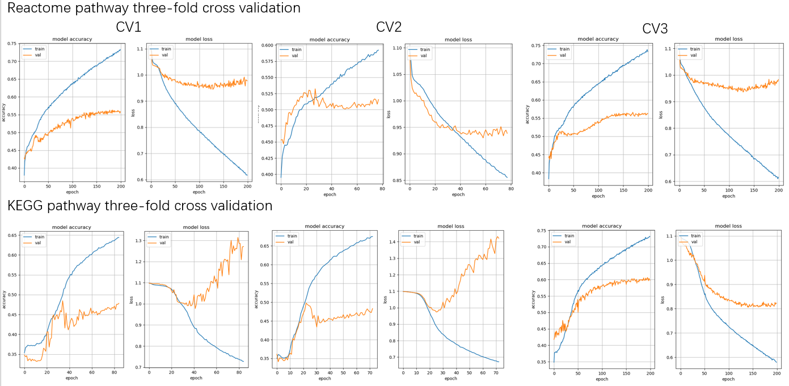

(Top) Training convergence plots of training and validation dataset for Reactome pathway three-fold cross validation. Left panels show accuracy plots and right panels show loss plots. (Bottom) Training convergence plots for KEGG pathway three-fold cross validation. The training process performed normally for Reactome database, but not for KEGG database: As the training process going on, the accuracy increased with the loss’s increment. Since loss function is a surrogate function of accuracy for optimization, here we used the accuracy of validation set as the index for early stop with a patience of 50 Epochs. Patience is the number of epochs with no decrease on loss or no increase on accuracy, after which the training process is stopped. We chose the final stop point to evaluate test dataset.